20/12/2023

Chakradhar Bhogapurapu, BIBA

Numpy

Numpy is a python library for doing mathematical calculations on arrays. Numpy deals with algebraic expressions, matrices

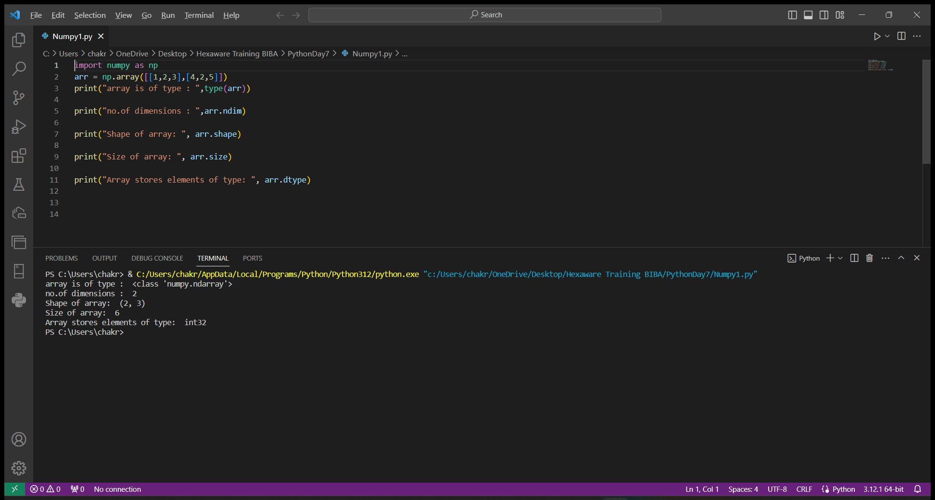

zeros() make an array with all zeros

full() takes the dimensions as parameter and the values to be inserted in array

arange() will give an array of provided input numbers

linespace() will give values in between two provided input values

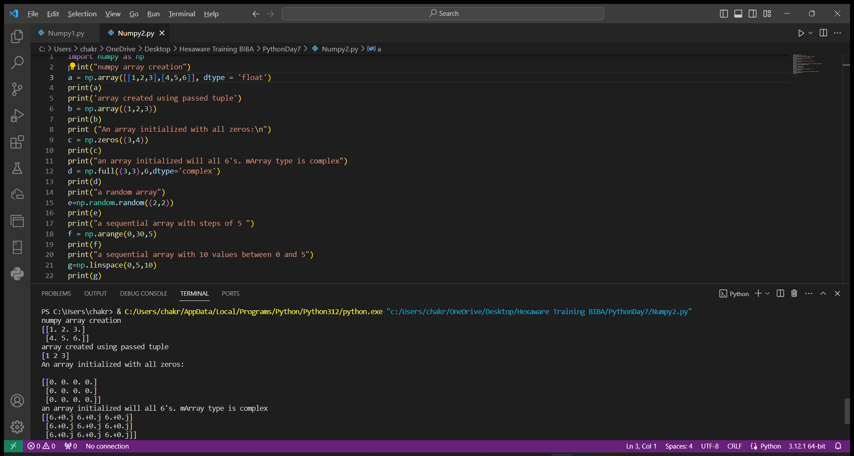

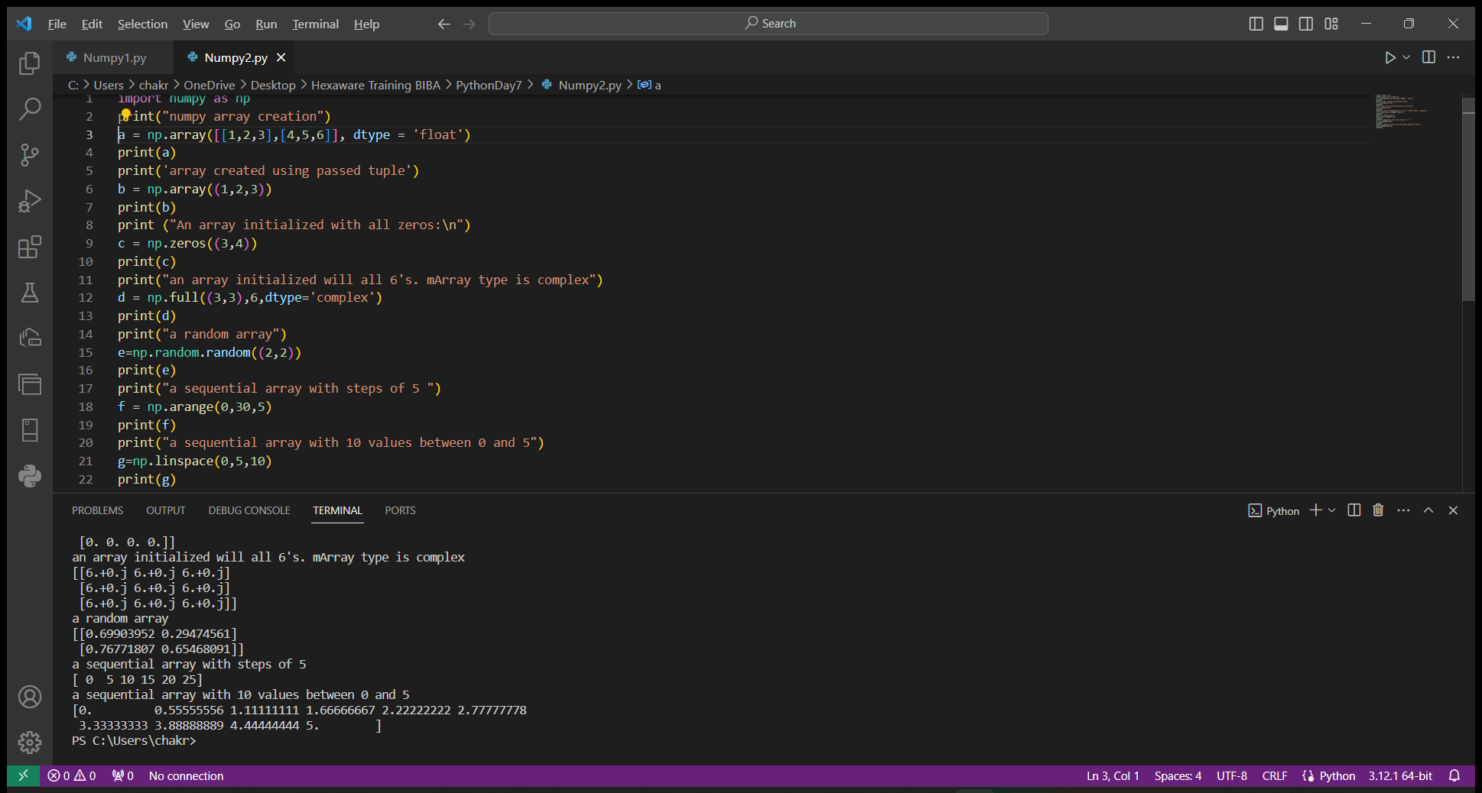

reshape() is used to reshape the array

flatten() is used to make the n dimensional array into one dimensional array

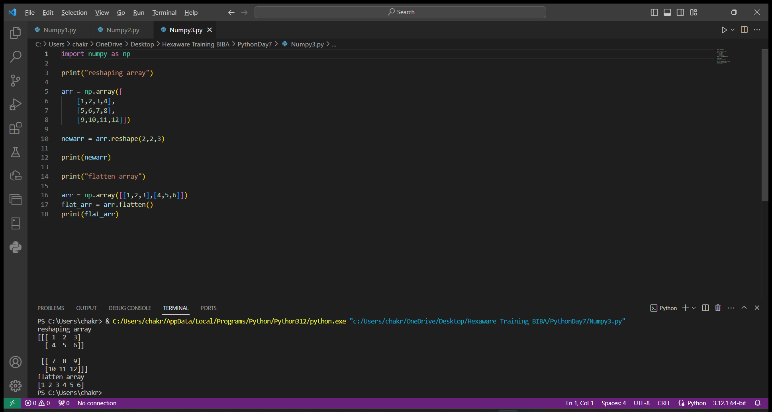

Array can be split and can be accessed by our choice. Indexing is given so that we get the desired value. 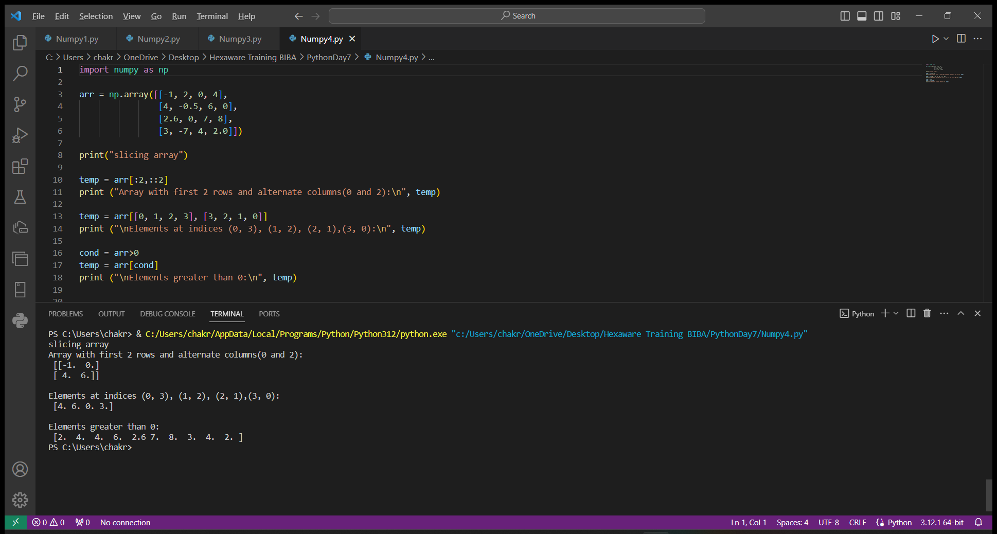

We can do mathematical operations such as addition, subtraction, multiplication, etc on values of array

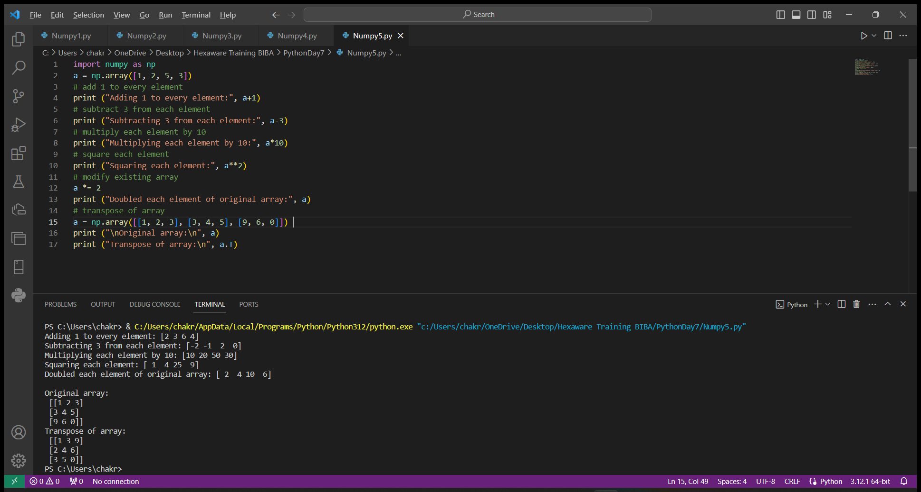

max() will give maximum value of array

min() will give minimum value of array

sum() will give sum of all values in array

cumsum() will give cumulative sum of array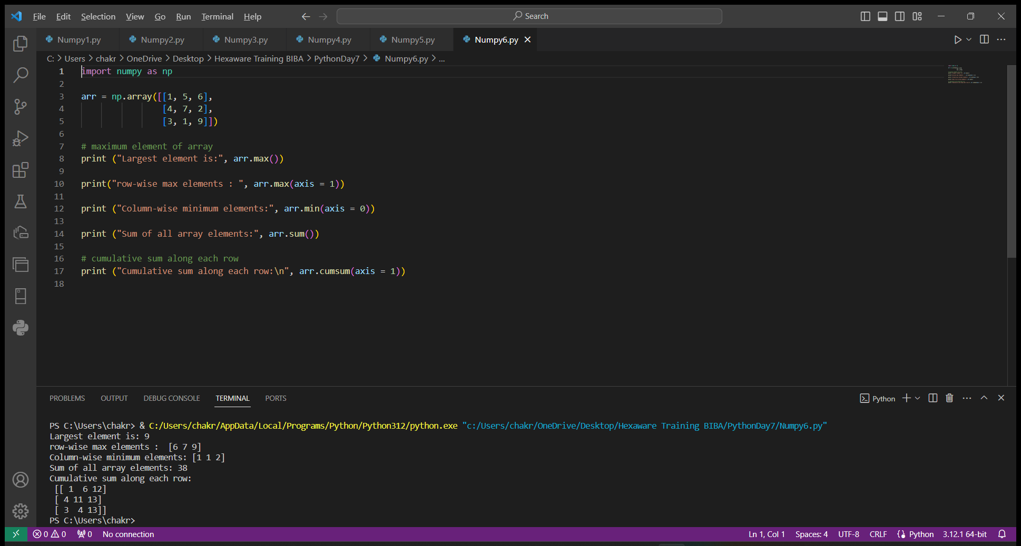

We can do mathematical operations on two arrays.

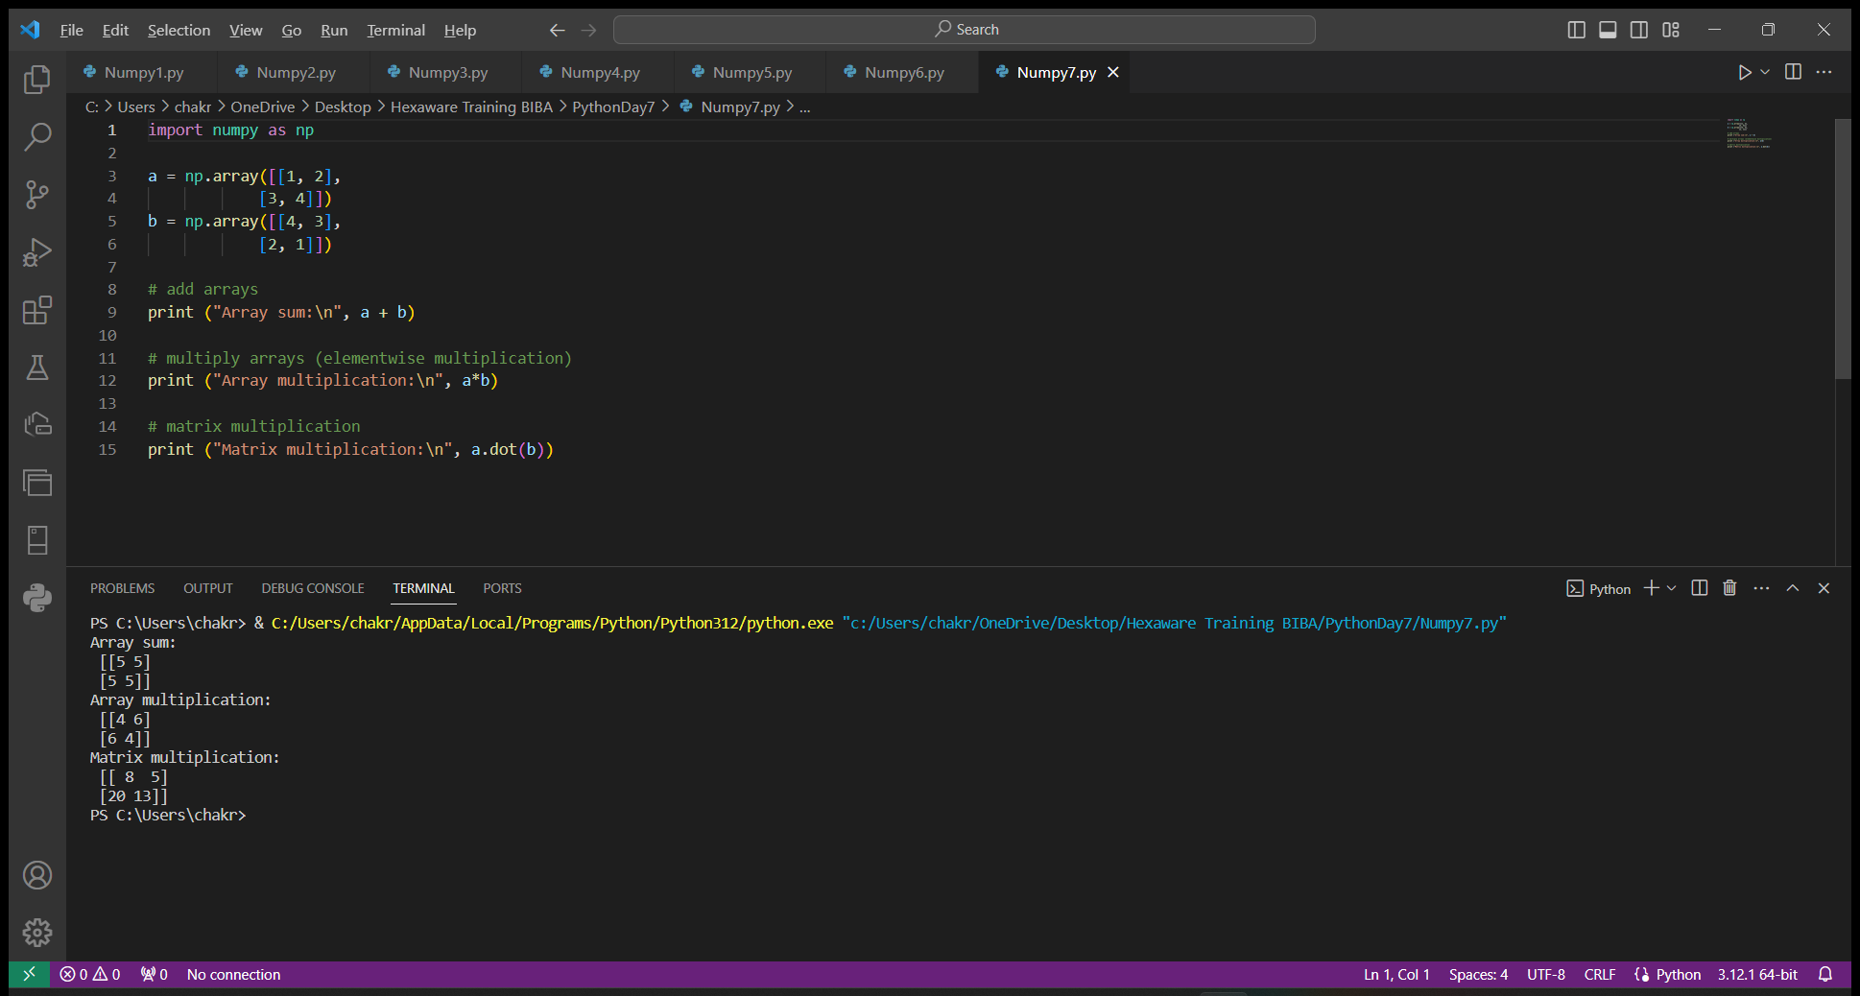

Trignometric expressions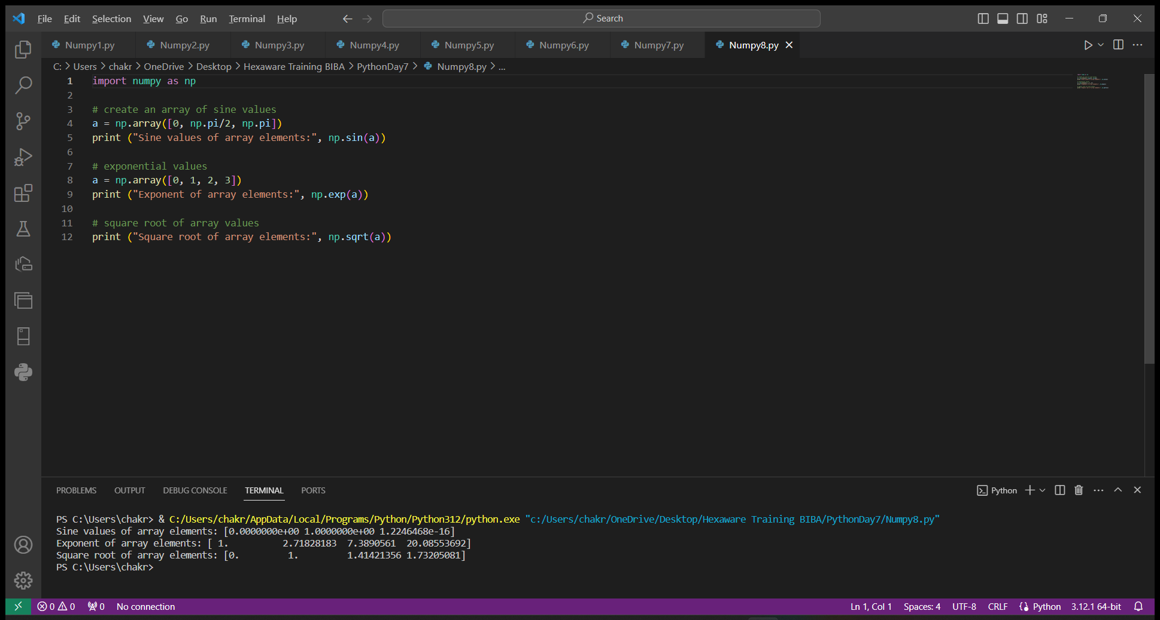

sort() will sort the array from small to big values based on axis.

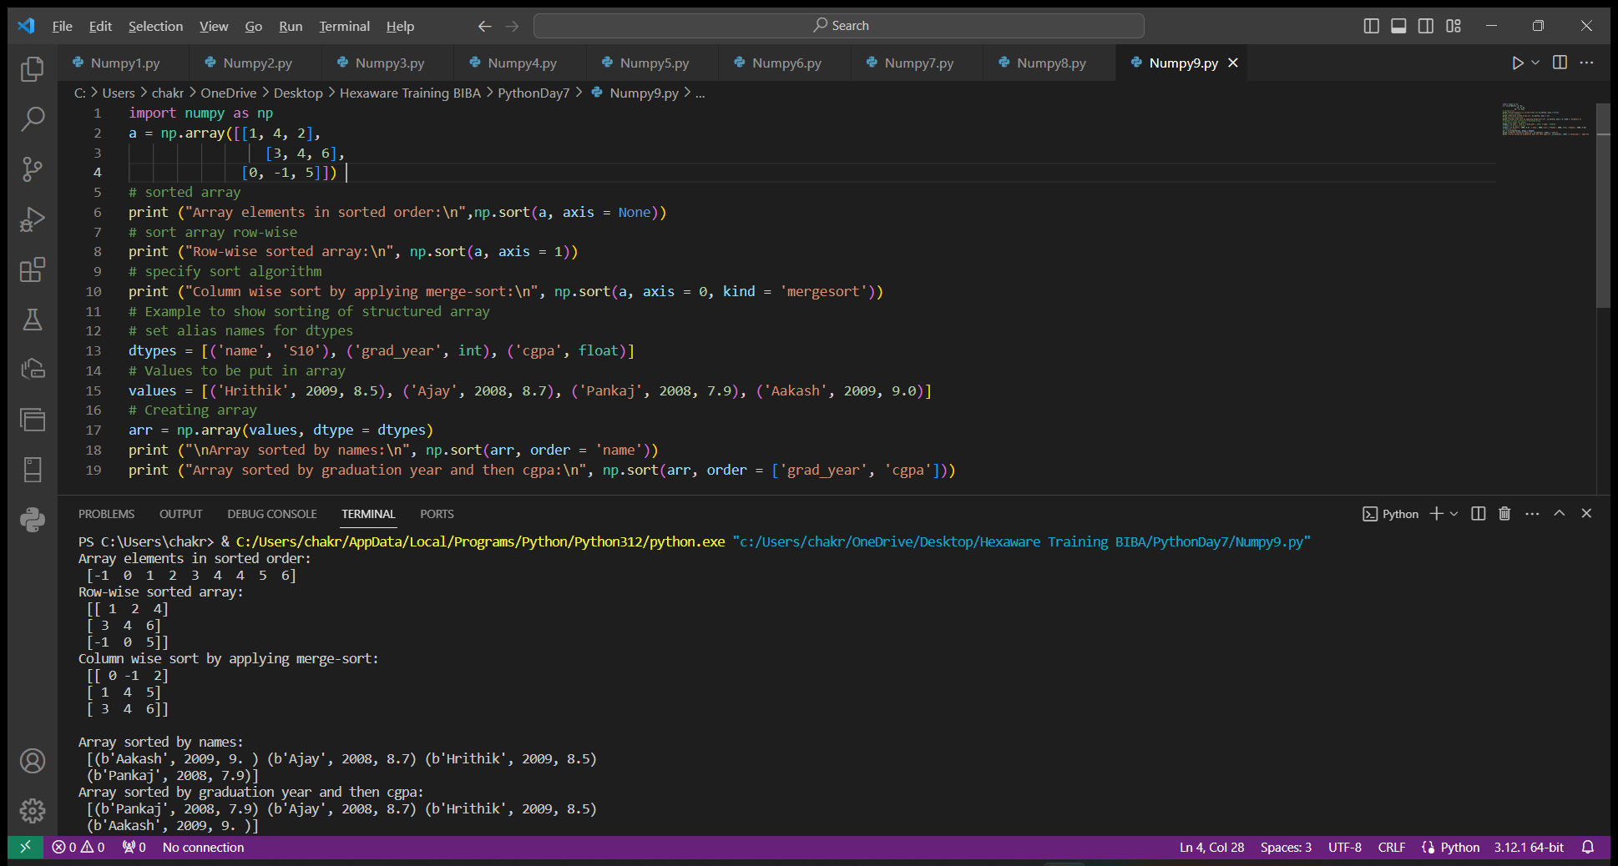

Big Data

Big Data is known as, data that has greater veracity arriving in increasing volumes and with more velocity.

Big Data is larger and has more complexity

Today, major companies are using big data concepts as to control the major customer data base.

Every day, tons of data is generated. This is handled using big data.